Cairo University  
Faculty of Computers and Artificial Intelligent

**CS251 - Software Engineering I**

Garage System

Software Requirements Specifications (SRS)

Mariam Osama Ahmed

Fouad Sayed Fouad

Mohamed Sayed Ali

5 & 2022

Contents

Instructions [To be removed] 3

Team 3

Document Purpose and Audience 3

Introduction 3

Software Purpose 3

Software Scope 3

Requirements 4

Functional Requirements 4

Non Functional Requirements 4

System Models 5

Use Case Model 5

Use Case Tables 6

Ownership Report 13

# Team

|  |  |  |  |
| --- | --- | --- | --- |
| **ID** | **Name** | **Email** | **Mobile** |
| 20200519 | Mariam Osama Ahmed | mo086388@gmail.com | 01110981070 |
| 20200384 | Fouad Sayed Fouad | foadsayed18@gmail.com | 01210950773 |
| 20200450 | Mohamed Sayed Ali | mohamedsayed415.ms@gmail.com | 01020467154 |

# Document Purpose and Audience

* This document tells us the requirements (functional/ nonfunctional), use case model, every use case description in this program.
* Audience → Customers who want to build a garage system.

# Introduction

## Software Purpose

* Build a strong infrastructure to the garage system.

## Software Scope

* Owner or receptionist must log-in to the system to interact with the system.
* Each vehicle must be identified by model year, model name, unique identifier number.
* Each vehicle must have a depth and width.
* System should display available slot if owner or receptionist want to show them.
* System will calculate total time automatically by subtracting arrival time from departure time.
* System will calculate fees by multiplying number of hours *5.
* Owner must input number of slots at the beginning.

# 

# Requirements

## Functional Requirements

1. Log in
2. Park in
3. Park out
4. Identification
5. Display available slots
6. Calculate total time
7. Calculate total income
8. Calculate fees
9. Slot dimensions
10. Vehicle dimension
11. Check out

## Nonfunctional Requirements

* usability:
* Customers should be able to access all relevant use cases with the fewest amount of mouse clicks and keystrokes possible.
* Performance:
* At least 100 customers and 1,000 reservations can be accommodated by the system. Over time, these figures should be multiplied tenfold or more.
* The system should reduce database connection times and provide customers with a speedy and painless experience.
* The system should always display the correct output to receptionist and customers.
* Reliability:
* Through the use of persistent storage and regular backup, the system should not lose a reservation.
* If the user interface disconnects from the system, the system should remember the details of the user's interaction.

# 

# System Models

## Use Case Model



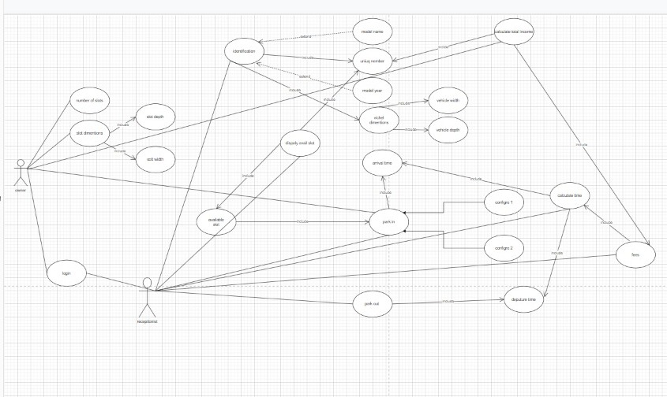

## 

## Use Case Tables

|  |  |  |
| --- | --- | --- |
| Use Case ID: | 1 | |
| Use Case Name: | Park-In | |
| Actors: | Owner, Receptionist | |
| Pre-conditions: | Vehicle must be identified in the system | |
| Post-conditions: | Vehicle has been parked in the garage | |
| Flow of events: | **User Action** | **System Action** |
| 1- Owner will select a one type of two configurations |  |
|  | 2- System stored the configuration |
| 3- Receptionist will make vehicle parked based on this configuration |  |
|  | 4- System will store the arrival time automatically |
|  |  | 5- System give unique identifier number to the vehicle |
| Exceptions: | **User Action** | **System Action** |
| 1- Owner enter configuration number |  |
|  | 2- Enter invalid password  3- System will send message to the owner to enter the password again |
| Includes | Arrival time | |
| Notes and Issues: |  | |

|  |  |  |
| --- | --- | --- |
| Use Case ID: | 2 | |
| Use Case Name: | Display available slot | |
| Actors: | Receptionist | |
| Pre-conditions: | Owner set the number of slots | |
| Post-conditions: | System will retrieve available slots | |
| Flow of events: | **User Action** | **System Action** |
| 1-Receptionits will select option of display the total income |  |
|  |  | 2-system will retrieve the available slots |
| Exceptions: | **User Action** | **System Action** |
|  |  |
|  |  |
| Includes: | Park in | |
| Notes and Issues: |  | |

|  |  |  |
| --- | --- | --- |
| Use Case ID: | 3 | |
| Use Case Name: | Fees | |
| Actors: | Receptionist | |
| Pre-conditions: | Vehicle must be parked out | |
| Post-conditions: | Customer can leave the garage by his vehicle | |
| Flow of events: | **User Action** | **System Action** |
| 1. Enter slot id which vehicle parked in |  |
|  | 2- System will calculate the time which vehicle has been parked at the garage |
|  | 3- System will calculate the total fees and retrieve it |
| 4- Receptionist ask guest to pay a fees and take it from him |  |
| Includes: | Calc time | |
| Notes and Issues: |  | |

|  |  |  |
| --- | --- | --- |
| Use Case ID: | 4 | |
| Use Case Name: | Park-Out | |
| Actors: | Receptionist | |
| Pre-conditions: | Vehicle must be parked in the garage | |
| Post-conditions: | Guest must go to pay a fees | |
| Flow of events: | **User Action** | **System Action** |
| 1- Receptionist check the unique identifier number |  |
|  | 2- System will retrieve a vehicle’s place |
|  | 3- System will store the departure time automatically |
| Exceptions: | **User Action** | **System Action** |
|  |  |
|  |  |
| Includes: | Departure time | |
| Notes and Issues: |  | |

|  |  |  |
| --- | --- | --- |
| Use Case ID: | 5 | |
| Use Case Name: | Total income | |
| Actors: | Owner | |
| Pre-conditions: | Owner log-in to the system | |
| Post-conditions: | Owner can know total income | |
| Flow of events: | **User Action** | **System Action** |
| 1- owner choose option total income |  |
|  | 2-system calculate the total income |
|  | 3- system retrieve total income |
| Exceptions: | **User Action** | **System Action** |
| 1- Owner Enter Password |  |
|  | 2- Enter invalid password  3- System will send message to the owner to enter the password again |
| Includes: | 1- fees  2- unique identifier number | |
| Notes and Issues: |  | |

# 

# Ownership Report

|  |  |
| --- | --- |
| **Item** | **Owners** |
| Document Purpose and audience/ Use case model/ Use case tables | *Mariam Osama Ahmed* |
| Software scope/ Use case tables | *Fouad Sayed Fouad* |
| Software purpose/ Functional & Nonfunctional requirements | *Mohamed Sayed Ali* |